DIVERSITY
exchanging ways of being
EVENT SPONSORSHIP, EXHIBITION & ADVERTISING APPLICATION
EVENT EXHIBITION: | First Class [$1,500 +GST] | EVENT ADVERTISING: | Full Page [$350+GST]
EVENT EXHIBITION: | Business Class [$1,000+GST] | EVENT ADVERTISING: | Half Page [$250+GST]
EVENT EXHIBITION: | Economy Class [$600+GST] | EVENT ADVERTISING: | Quarter Page [$150+GST]
EVENT EXHIBITION: | Poster Display [$250+GST] | EVENT ADVERTISING: | Please contact me to discuss opportunities
- Applicants may apply for more than one of the above options
- All sponsorship, exhibition & advertising opportunities / entitlements are subject to negotiation and availability; exhibition space is limited at this event
- Full details and Tax Invoices will be forwarded following receipt / approval of applications
Applications available until sold out

Applicant Details
Name:
Organisation: |  | Email:
Address: |  |  |  | P/C:
Phone: |  | Website:
Please contact me regarding additional items or information



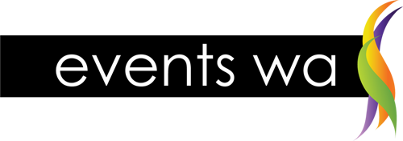
Conference Office
Post PO Box 414 Greenwood WA 6924 Phone +61 8 6142 1042
Email ralph@eventswa.com.au Fax +61 8 9272 4262

